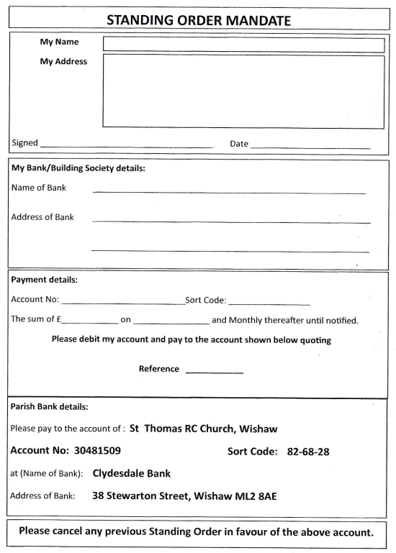

Information Sheet – Please read carefully
St Thomas’ Gift Aid Scheme

It is estimated that each year, 600 million pounds of Gift Aid are unclaimed. At a Parish level, we lose out if you are a taxpayer but not a member of the Gift Aid Scheme. This Scheme is designed to allow anyone who is currently paying income tax to “Gift Aid” their donations so that we can claim that tax back from HM Revenue and Customs. HMRC adds an additional 25p for every £1 you donate. It costs you absolutely nothing, but it can generate a lot of needed income for this Parish so, please, if you are not a member and pay income tax, complete the attached form, and hand it in to Fr Krzysztof. It takes only a minute or so. We’ll issue you with a special set of envelopes to allow us to track your donations or you can choose to pay through a Bank Standing Order. If you pay by standing order, that should go directly into the St Thomas’ bank account: 30481509 with sort code: 82-68-28.
You are not committed in any way to a particular amount and can increase or decrease your donations as you wish or leave the Scheme at any time.
If you are an existing member of the scheme, we want to thank you so much for your support. So long as you are still paying tax, please continue to use the envelopes for your donations.
If you should have new envelopes and they are not there for collection, please get in touch with the Gift Aid Administrator who will sort that out for you. We know that on occasions, people from here attend Mass at St Patrick’s and vice versa. Please continue to use the envelopes no matter where you attend, and they will be returned to the appropriate Parish for logging, so we don’t lose out at all.
If you miss any opportunity to donate and want to add that into a subsequent donation, that’s absolutely fine. There is no need to use an additional envelope just put both donations in the one envelope.
My earnest plea is for anyone who currently pays tax and who is not a member, to become involved as soon as possible. It’s an easy way to increase the value of anything you give to St Thomas’ without any cost to you whatsoever. Please join!
Thanks so much and don’t hesitate to get in touch with me if I can help.
John Di Mambro (Gift Aid Administrator)
E-mail: johndimambro@gmail.com
Mobile: 07505233652
April 2022
Please complete the form opposite and return it to Fr Krzysztof
